**10. Work with chart repositories**

**# Add bitnami repository to your repositories.**

--- helm repo add bitnami <https://charts.bitnami.com/bitnami>

**# List repos**

--- helm repo list

**# Search apache chart in bitnami repo**

--- helm search repo apache

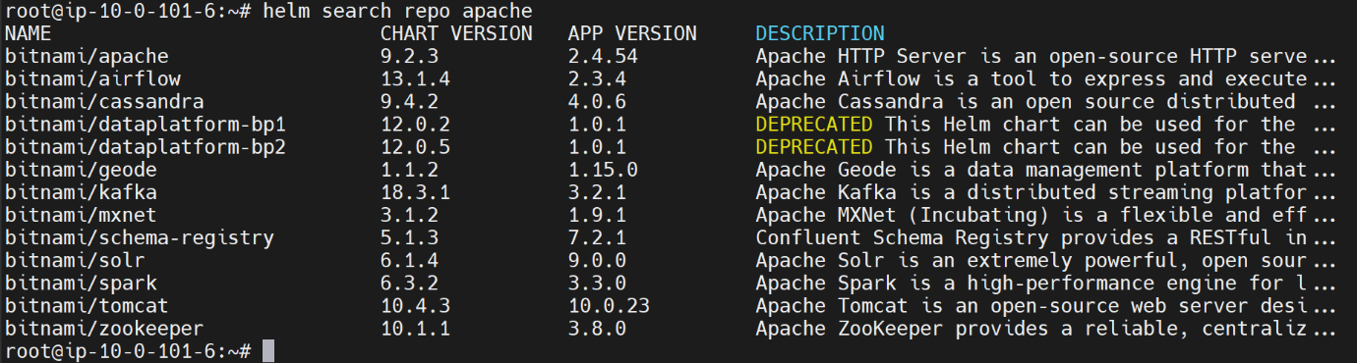

--- **note** – you have chart version and app version.

--- **note** – by default, you will only see the latest version of apache. If you want to see the all the versions of apache then execute the below command.

**# To see the all the version of apache.**

--- helm search repo apache --versions

**# Remove the repository**

--- helm repo remove bitnami